Data Analytics Assignment 2 Report

**Part 1.**

**a).** 1. Central Tendency of EPI:

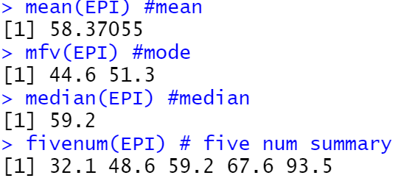

Figure 1. Central Tendencies of EPI

2. Histogram for EPI variable shows the frequency distribution of Environmental Performance Index (EPI) value across all locations.

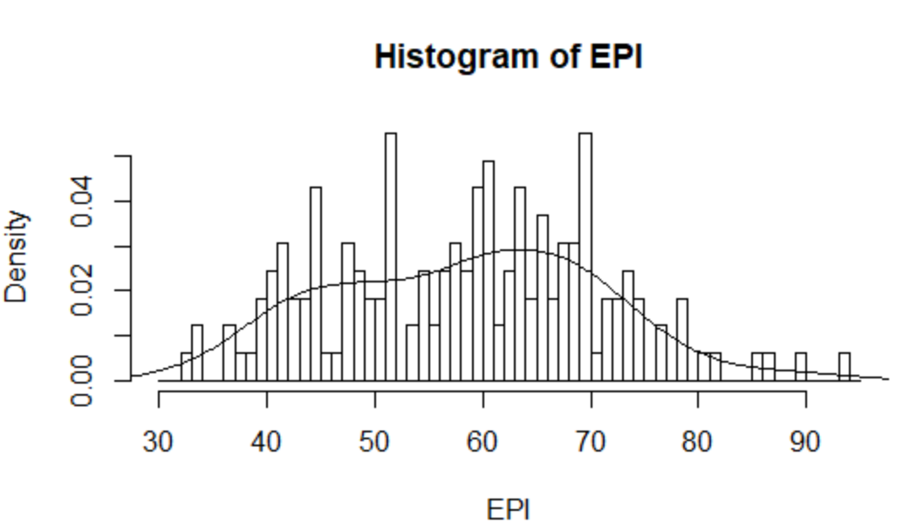

Figure 2. Distribution Histogram of EPI

3. Histogram for DALY variable shows the frequency distribution of disability-adjusted life year (DALY) across all locations.

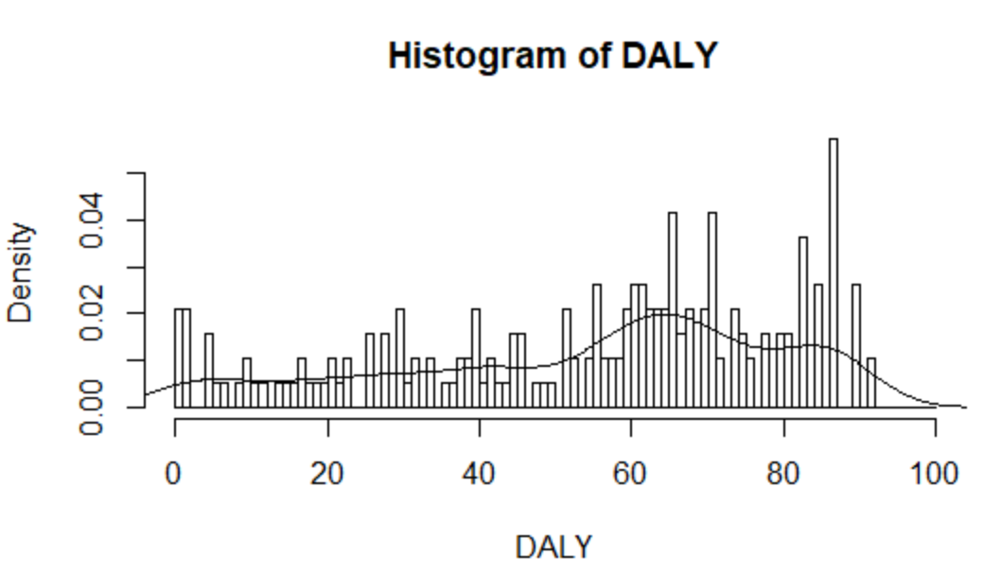

Figure 3. Distribution Histogram of DALY

4. The two box plots below provide visual summary of central tendencies and spreads of ENVHEALTH score, ECOSYSTEM score and compare them side by side, clearly showing the interquartile range and the outliers of each.

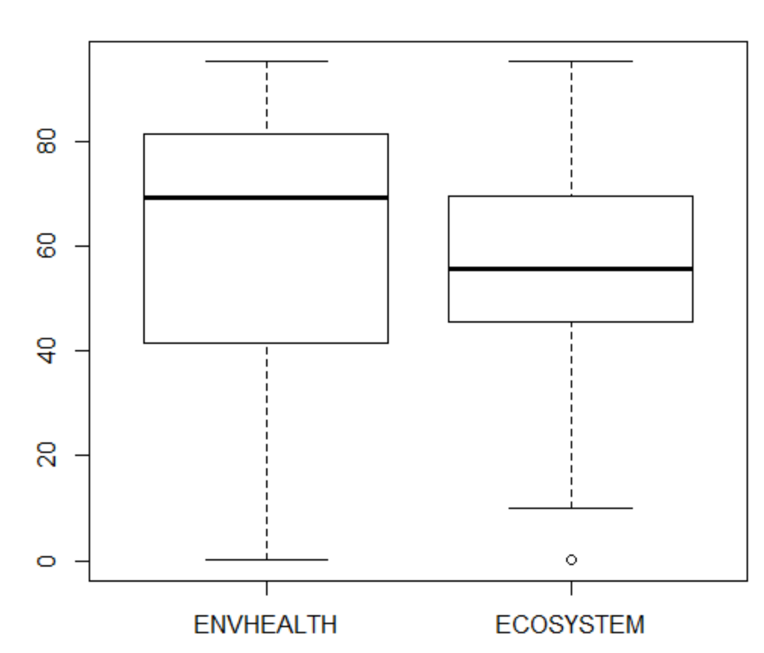

Figure 4. Boxplots of ENVHEALTH and ECOSYSTEM

5. A Q-Q plot basically compares two distributions. If two distributions are exactly the same, all the points should lie on the y = x line. However, the plot below indicates that the distributions of ENVHEALTH and ECOSYSTEM are not the same, meaning that the density. We can further verify this conclusion by plotting and comparing both distribution lines of ECOSYSTEM and ENVHEALTH on a single graph as shown in the Figure 6 below.

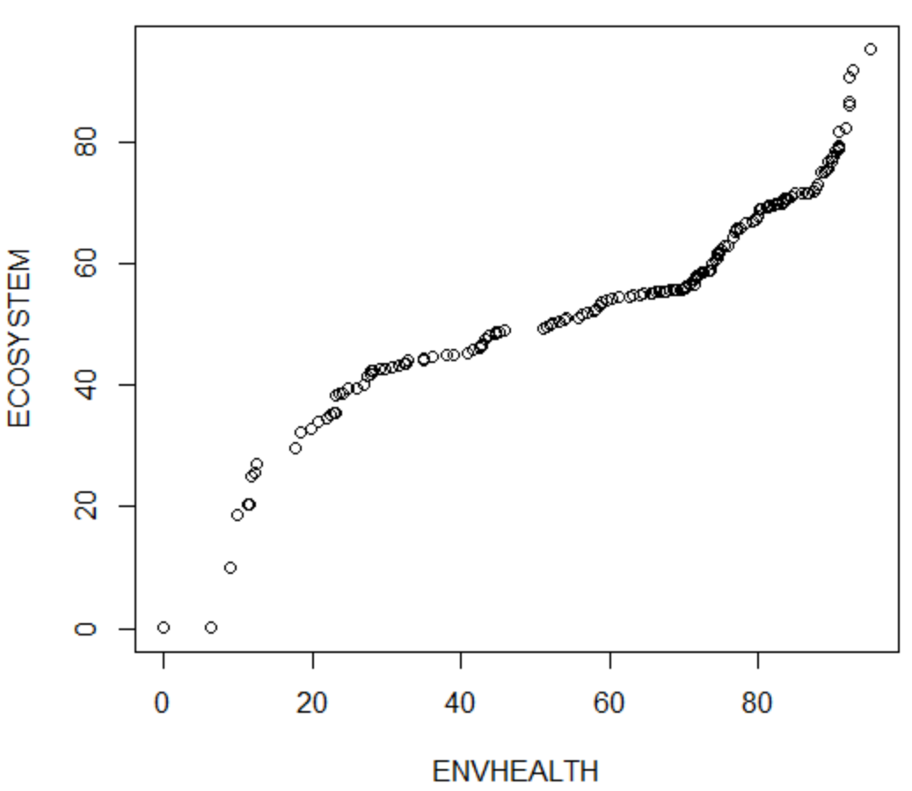

Figure 5. Q-Q Plot for ECOSYSTEM and ENVHEALTH

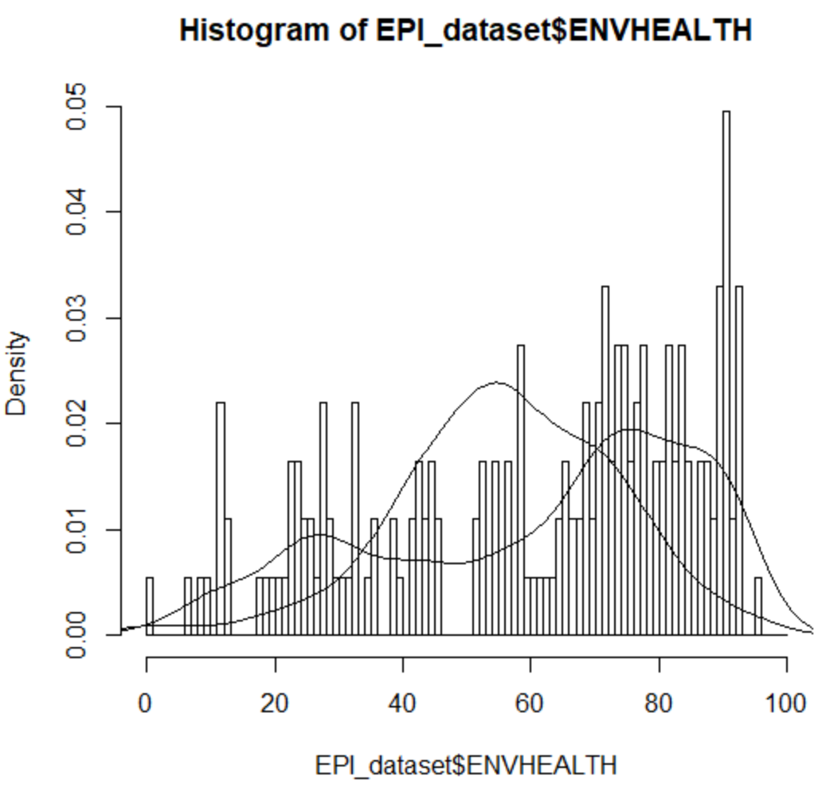

Figure 6. Distribution Lines of ECOSYSTEM and ENVHEALTH

**b).**

1. The features that are mostly correlated (important) to EPI can be figured out by using the built in *cor()* function to generate a correlation list. Then, the features with high correlation coefficients can be easily identified by sorting the list, as shown in Figure 7 & 8 below.

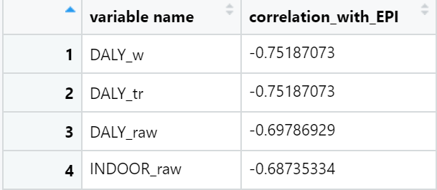

Figure 7. The Most Positively Correlated Features

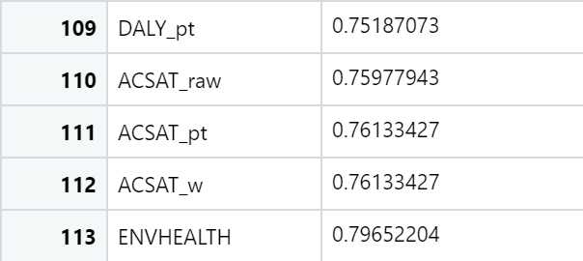

Figure 8. The Most Negatively Correlated Features

2. A linear regression model is built and used to generate predicted values to show linear relationship between ENVHEALTH and some selected features. According to the summary shown in Figure 9, the equation can be written as below. And a snippet of the predicted ENVHEALTH results for our artificial data is shown in Figure 10. Row one means that with all independent variables being set to 5, the predicted $ENVHEALTH$ value will be 5.000048, with a 95% of confidence interval between 4.993824 and 5.006272.

*Equation 1.*

$ENVHEALTH = 0.5 * DALY+0.25 * AIR_H+0.25 * WATER_H – 2.67 * {10}^{-5}$

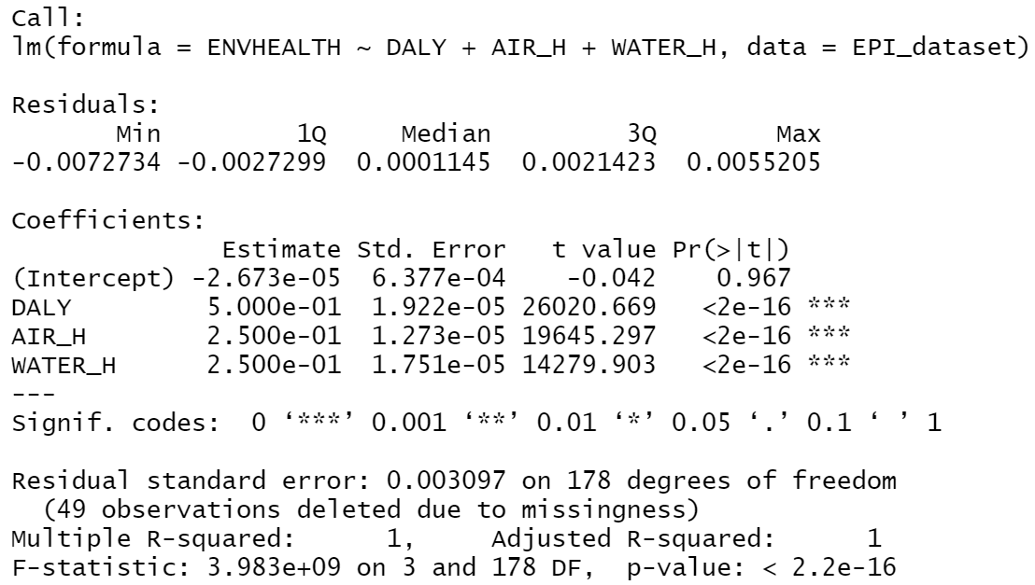

Figure 9. Linear Regression Summary

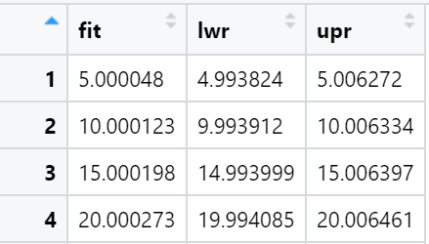

Figure 10. Snippet of the Predicted Results

3. Then, similar processes are applied to variable **AIR_E** and **CLIMATE**. Summaries are shown in Figure 11 & 12 below. Noted, variable **DALY** is not significant enough for explaining **AIR_E**, and **AIR_H** is not significant enough for explaining **CLIMATE** at 95% confidence level.

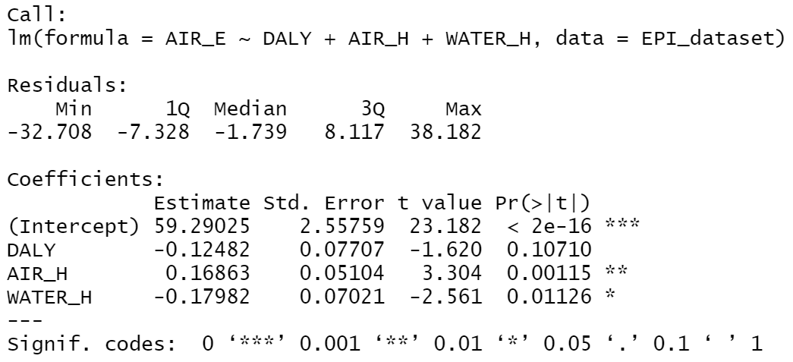

Figure 11. Summary for AIR_E Regression

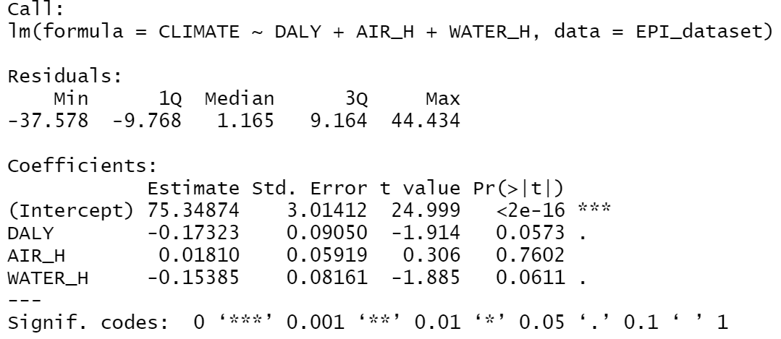

Figure 12.Summary for CLIMATE Regression

**Part 2.**

**Exercise 1).**

In this exercise, we build two linear regressions to find the linear relationship between enrollment (ROLL) and some selected features. Equations and predicted results are shown as below.

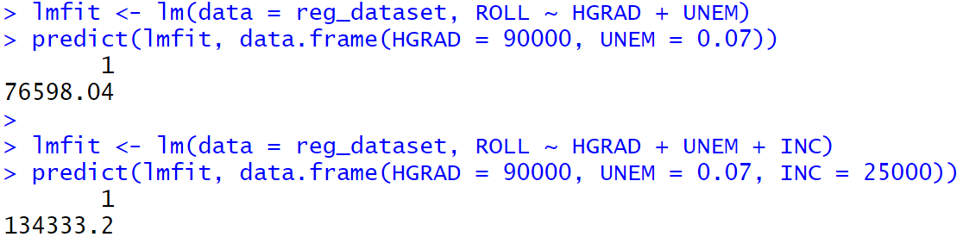

Figure 13. Multiple Regression Exercise

**Exercise 2).**

In this exercise, we build a KNN model to predict abalones’ age label (i.e. young, adult, old) using several selected features. Since the random seed is not fixed, the predicted result will have some variation but the testing (out of sample) accuracy is always similar at around 66% - 68% with a train test split of 7:3 and k = 55.

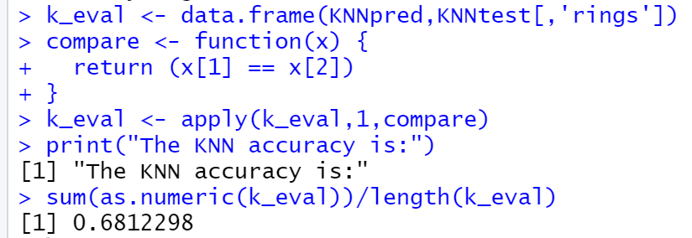

Figure 14. KNN Accuracy

**Exercise 3).**

In this exercise, we are using K-means to cluster iris type based on their sepal length, sepal width, petal length, and petal width. If we were to use only two of the features, visualizations of the attribute will be easy to comprehend as shown as Figure 15. But, in this problem, we are using all four of the features, so that actual algorithm will run on a 4-dimensional graph which cannot be graphed with any existing tool. However, we can still see the clustering result in a table format. Configurations and results are shown in Figure 16.

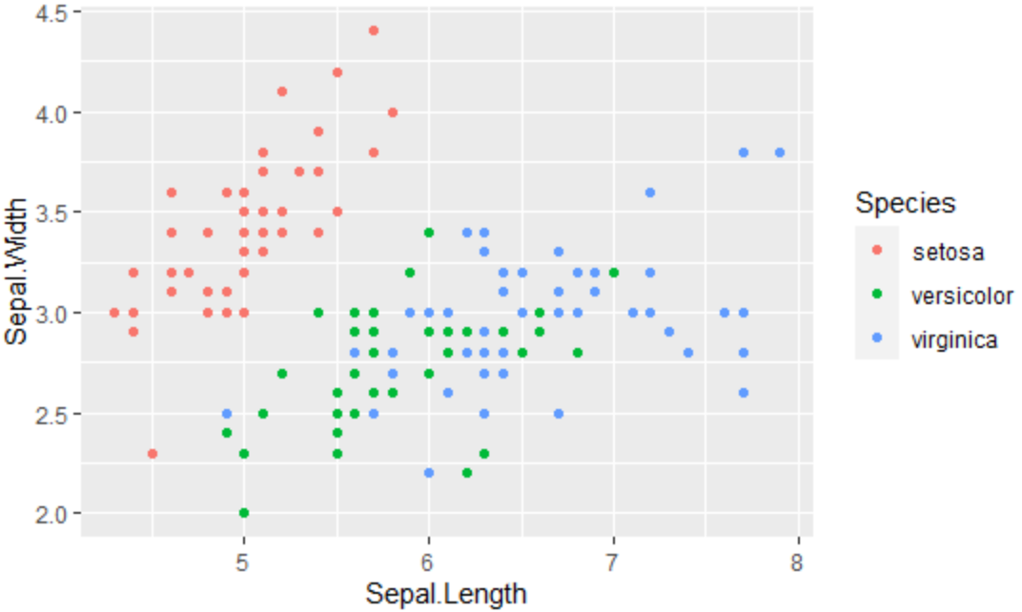

Figure 15. 2-D Visualization

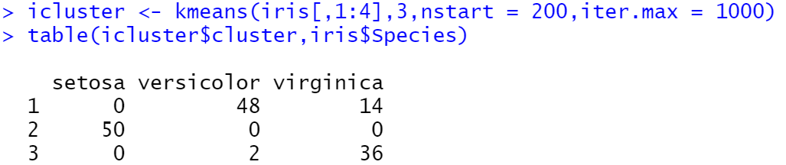

Figure 16. Clustering Result